CLIENT INFORMATION

Screen Shot:
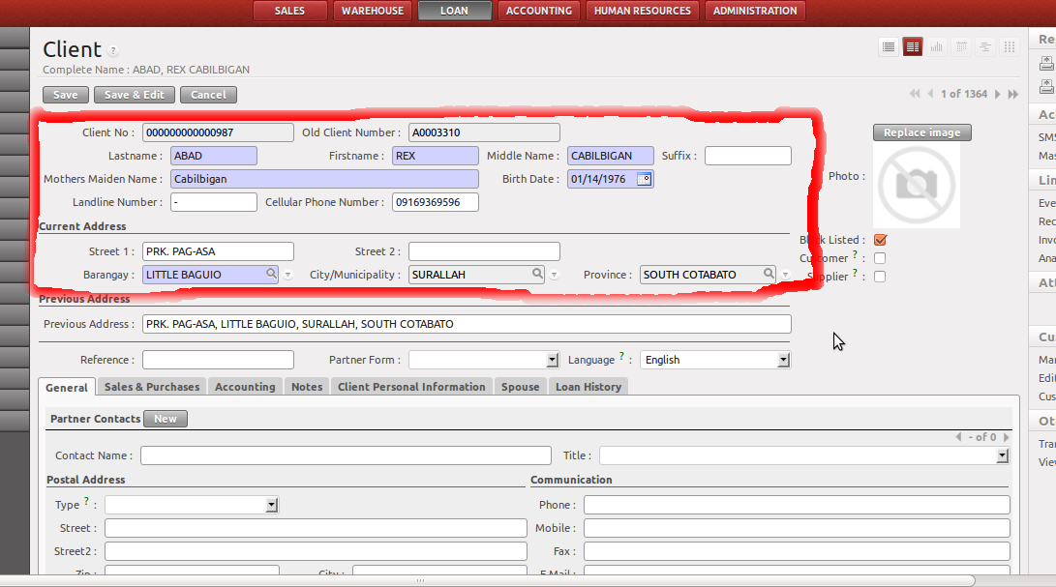
Required Config Modules
Province – Loan >> Configurations >> Localization >> Province
Municipality – Loan >> Configurations >> Localization >> City / Municipality
Barangay – Loan >> Configurations >> Localization >> Barangay

Mimimum/Required Data for New Client Record:
- Lastname
- Firstname
- Middlename
- Mother's Maiden Name
- Birth Date
- Barangay

Additional Information:
- Maintain 1 client ID for 1 client. This is for easy monitoring of the client's credit history.

